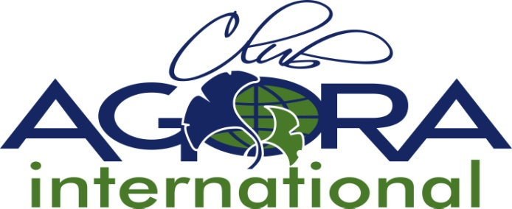

6. Application Form Full Membership

Please complete and return to the ACI Secretary before the 30th June
by mail secretary@agoraclubinternational.com

Name of applying AC Country:

International Godmother Country:

Charter date and name of Agora Club N° 1 :

Charter date and name of Agora Club N° 2 :

ACI rules regarding Full Membership applications:

3.3 Full Membership
3.3.1 When an Associate Member country fulfils each of the following conditions, that
country may apply for Full Membership of ACI:
a. There shall be a minimum of two Clubs in the country.
b. There shall be an elected National Board, which can be created if there is a minimum of 2 clubs in the country
c. The ACI Board shall have approved the National Association's Constitution and Rules.
d. The International Board shall have a list of the applicant’s National Board members
and their addresses.
3.3.2 The official application for Full Membership has to be sent to the ACI Secretary by the 30th of June prior to the ACI AGM at which it will be considered, and shall be included on the ACI AGM Agenda and voted for by the ACI Councilors.
3.3.3 From the moment Full Membership is granted, a new Full Member country shall have 2 votes and the right to propose new or amend existing rules. It can host an ACI Conference and/or propose candidates for ACI Office.
3.3.4 If the number of Clubs in a Full Member country remains only 2 for three consecutive years, its Full membership will be reconsidered.
3.3.5 For Full Membership to be considered at the ACI AGM, the country applying must have representation by at least one member at the ACI AGM at which it will be considered.

Year of inauguration of the National Board

Number of active members at time of application:

Years and places, when the applying country was represented at ACI conferences:

The National Aims and Objectives, the National Rules and National Logo and Banner are attached to this application form.
(to be approved by ACI board)

Date of Approval by ACI board:
(to be filled by ACI board ):

APPROVAL OF THE NATIONAL ASSOCIATION:

The AGM of the National Association must (have) approve(d) the application for Full Membership, before sending this form.

Approved by the applying Agora Country’s (National) President

Name and signature Date

Approved by the Godmother Country’s (National) President :

Name and signature Date

Any other information:

